**“SMART ELECTRICITY BILLING SYSTEM”**

**Er. Vinit Tirnagarwar.**

E&TC Department, Bharati Vidhyapeeth Pune, India.

***Abstract****—Scope for smart energy billing system is increasing rapidly because of electricity theft in rural and sometime in urban area Power theft is the biggest problem in recent days which causes lot of loss to electricity distributed. In countries like India, these situations are more severe. If we can prevent these thefts we can save lot of power. Smart electricity billing system is an automatic electric device having energy meter chip for measuring the electric energy consumed and a wireless protocol for data communication.*

*This paper presents a smart energy meter for an automatic metering and billing system. In this meter energy utilized and the corresponding amount will be displayed on the dedicated app continuously and communicated to the corresponding IOT base server. The recorded feedback from the android app helps in identifying the usages between users which helps in controlling the power theft.* *Communication between user and meter is established using TCP(IOT).On system sensor communication is done by USART communication. This meter can work as either prepaid or post-paid meter depending on user configuration. The proposed system may replaces traditional meter due to better monitoring capability over traditional meter and remote access of existing energy meter by the energy provider. Also they can monitor the meter readings regularly without the person interaction due to IOT support.*

*Present paper describes a model, which is done by using several software’s like proteus dip-trace and many more.A prototype of the proposed energy billing system is built and tested to analyze the performance of the system.*

***Keywords: Universal Synchronous and Asynchronous Receive and Transmission (USART), Internet of things (IOT), Transmission Control Protocol (TCP).***

**I. INTRODUCTION**

Power theft and pending electricity bills are the biggest problem in recent days; proposed module is designed to overcome these conventional problems. Complete system partly divided into two major parts.

* Electrical data acquisition.
* User and Module communication.

1. In Proposed project, module uses voltage sensor and current sensor to measure voltage and current. Real time clock is interfaced with the controller to get time. After obtaining three parameters power is calculated and real time is recorded for complete power consumption. This project prepaid billing system is programmed to cut-off electricity when consumer exceeds capacity. Over voltage and short circuit protections are provided in the system.
2. Digital ways of data sharing like TCP/IP UART, I2C are implemented into the system. All real time data is transferred to android app through Wi-Fi module esp-8266. Data sharing between controller and android application is done by TCP protocol. On board communications for esp-8266 UART protocol and for RTC I2C protocol is used.

**II. BLOCK DIAGRAM AND DESCRIPTION.**

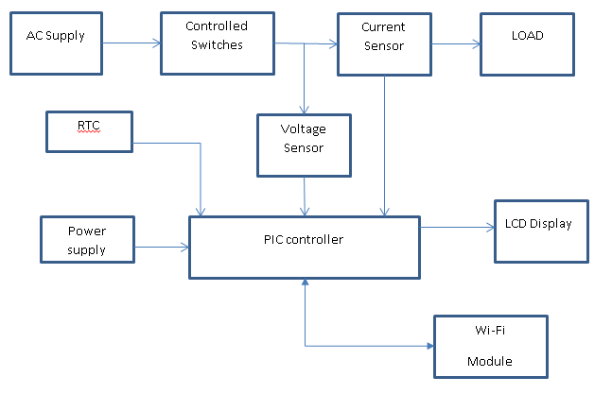

**Fig 2.1: Block diagram of Model**

* Controller- P18f4550 is an advance 8bit microcontroller having eight analog to digital converter channels. All controlling action will be done by PIC micro controller. Specific switching commands to the controller are given by wi-fi Module.
* Wi-Fi- Esp8266 is a 2.2-2.4 Ghz Wi-fi Module. it have the compatibility with TCP/IP

protocol for data sharing and transferring. It can easily connect to the internet and data and command are directly share via internet.

* Current Sensor- WCS1700 is used as a current sensor it have the m15 Amp measuring capacity. Particularly it is used to measure one of the important parameter Current. This value is helpful for giving over current protection signal to controller
* Voltage Sensor - Resistive voltage divider is used as a voltage sensor it have the 400Volt measuring capacity. Particularly it is used to measure one of the important parameter voltage. This value is helpful for giving over voltage protection signal to controller.
* RTC (Real time clock)- A real-time clock is a computer clock that keeps track of the current time. Although the term often refers to the devices in embedded systems. In this project DS1307 RTC chip is used to keep track in time and to calculate Energy for particular duration.
* Controlled Switches- To connect or disconnect the switch command is given by the controller. So to read this command and act according to it the Power electronic switch like triac or electromagnetic switch like relays are used.
* Power Supply- 5v 1amp on board linear power supply is designed which will be directly power up from main and will be sufficient to run all components on the board.
* Loads- It can be any home electrical appliance load which is linear in characteristic.

**III. CIRCUIT CONFIGURATION**

**SOFTWARE INFORMATION**

* Simulation software

Proteus V2.0

developed by lab centre electronics

released in 1988,England.

thousands of electronics component library provided

also support PCB layout Designing.

* PCB Design Software

DipTrace 3.2.1

deeloped by "Novarm Ltd."

CAD based software for schematic design.

auto routing and 3D PCB Preview provided.

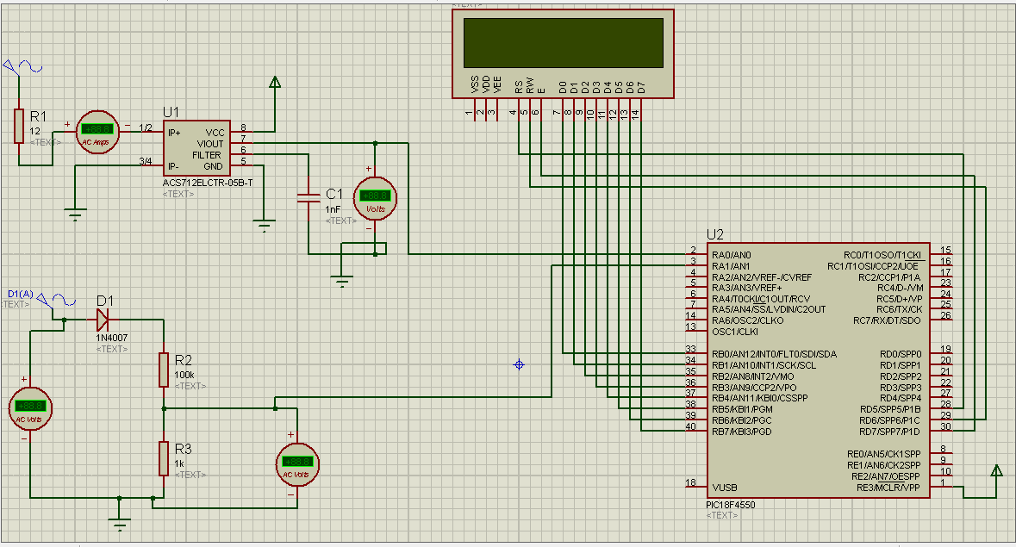

**Fig 3.1:** Simulation Prototyping.

[A]: Model Simulation.

Basic system module is designed on proteus simulation environment for basic module and programming testing, software description are explained as above in same section.

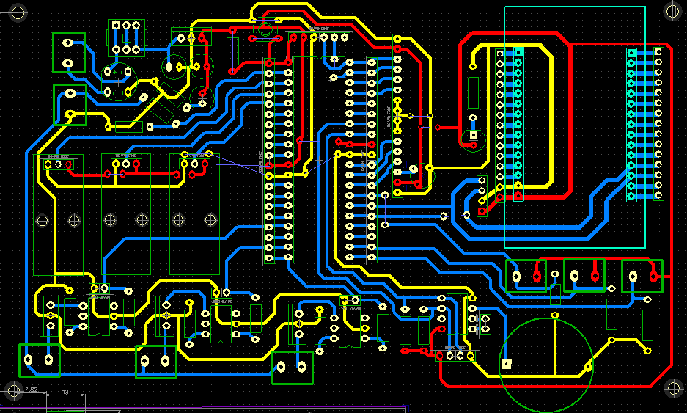

**Fig 3.2.1:** PCB design of module

[B] Model designing.

Hardware module is designed on Dip trace PCB designing software, software description are explained as above in same section.

**IV. PROTOTYPE MODULE.**

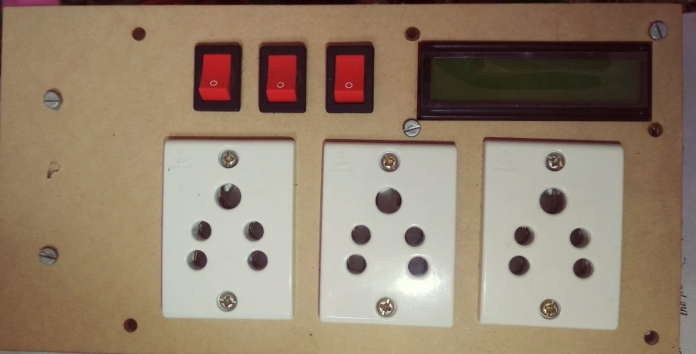

**Fig 3.3:** Prototype Module

Prototype Module is built after circuit simulation PCB designing is done as shown in fig 3.2.1 by using dip-trace software and proteus simulation. Prototype module important parts/components are explained as below

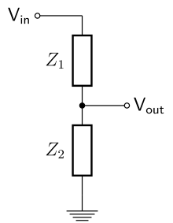

**Fig 3.3.1:** Voltage Sensor Circuit.

Module 1: voltage sensor circuit.

Voltage divider is used to measure AC voltage of supply. It’s output values are analog values which are transferred to micro-controller. Controller converts analog value to digital using ADC and digital values of voltage are obtained.

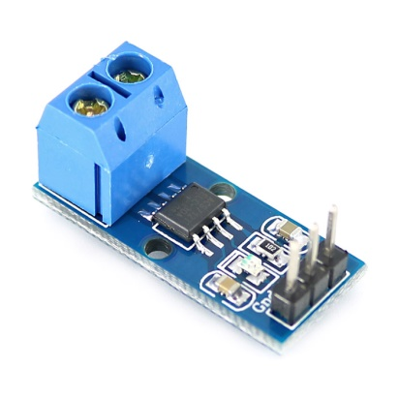

**Fig 3.3.2:** Current sensor Circuit.

Module 2: Current sensor.

ACS712 current sensor is used it posses the characteristics of measuring 15 Amp current AC/DC. Module output is Analog. Controller converts Analog value to digital and obtain current values

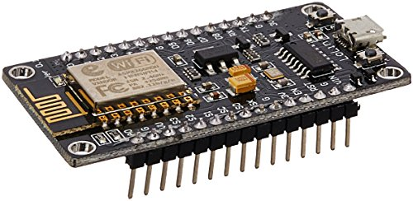

**Fig 3.3.3:** Wi-Fi module.

Module 3: Wi-fi Module

NODEMCU/Esp-8266 is an open source IOT platform. It can easily connect to any network via Wi-Fi or it can act as a server for particular Devices.

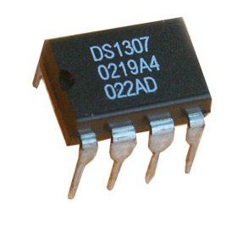

**Fig 3.3.4:** Wi-Fi module.

Module 3: RTC Module

Real time clock chip keep the track of real time environment. It works on Two Wire Interface.

**V. ANDROID APPLICATION**

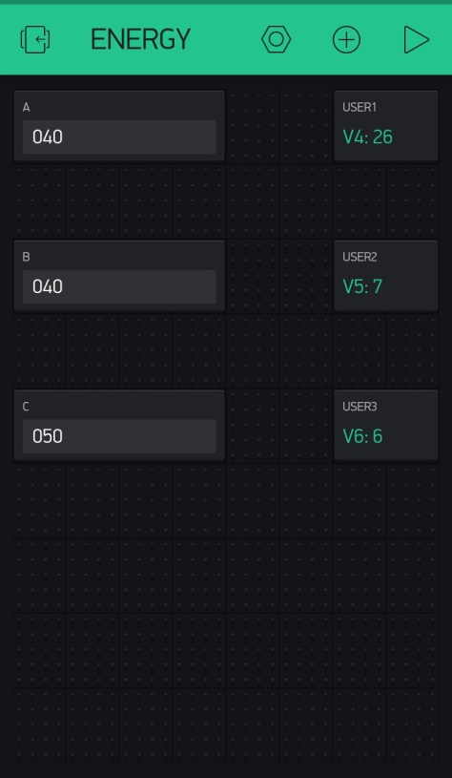

**Fig 3.4:** Android application.

Android application is built with the help of Blynk platform. Blynk platform is an open source user space where easily application and server communication can be established. Particularly in this android application user power consumption limit is set and real time power consumption is monitor as shown in fig 3.4.

**VI. EXPERIMENTAL RESULT**

Following results are obtained after experimentation of prototype model.

* Successfully monitoring and recording current, voltage, power, and energy values.
* Marinating prepaid billing system and cut-off electricity supply after crossing prepaid range.
* Receiving and transmitting data from and to android application.
* Real time monitoring over android application.
* Over voltage and over current protection enabled successfully.

**VII. CONCLUSION**

By using proposed module energy consumption measuring done effectively. Each consumer energy usage recorded and maintained also prepaid billing system is implemented successfully. Due prepaid billing system energy consumption managed effectively.

**VIII. REFERENCES**

[1] Vivek Kumar Sehgal, Nitesh Panda, Nipun Rai Handa,, Shubhrangshu Naval and Vipul Goel “Electronic Energy Meter With Instant Billing”UKSim Fourth European Modelling Symposium on Computer Modelling and Simulation

[2] Md. Manirul Islam1, Mohiuddin Ahmad1,, Md. Ajijul Islam1, Abu Farzan Mitul1, M. F. Malek2, and M. A. Rashid2,* “Electronic Energy Meter with Remote Monitoring and Billing System”**2012 7th International Conference on Electrical and Computer Engineering.**

[3]Sarwar Shahidi, Md. Abdul Gaffar, Khosru M. Salim, Electrical and Electronics Engineering, Independent University, Bangladesh. “Design and implementation of Digital Energy Meter with data sending capability using GSM network.”,**Proceedings of 2013 2nd International Conference on Advances in Electrical Engineering (ICAEE 2013) 19-21 December, 2013, Dhaka, Bangladesh.**

[4]Chris Loeffler,“UPS Basics” , Eaton Corporation, Thought Leadership White Paper, **http://**www.eaton.com/pq/whitepapers.